The Grand(ma) Knit-a-Ton

Grannies Gloria White and Georgia Black have made a bet: whoever knits a scarf the fastest will be the greatest mother-knitter of all time.

The Knitting Gods think this will be pretty fun to watch, so they give the Grannies some Knitting Blessings (cards) to help them out.

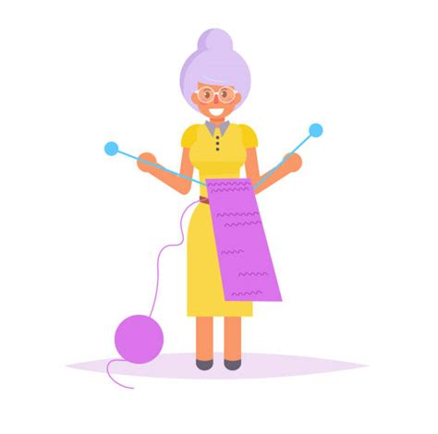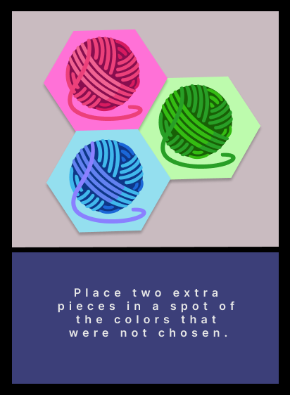

Pieces:

- 60+ pieces for Granny White

- 60+ pieces for Granny Black

- 50+ pieces for spot blocking

X

- 40 Knitting Blessings (cards)

**Gameplay:**

1. Each Granny starts out with 4 Knitting Blessings (cards).
2. Each round, the Grannies take turns rolling the die; whichever number they roll is how many Knitting Blessings they are allowed to play that round.

1. Knitting Blessings allow you to choose between placing scarf pieces on the board – or to trip up your opposing Granny.

When using a Knitting Blessing:

* 1. Each card comes with two options: knit another piece of your scarf into any empty spot that has one of the colors represented on the top or use the Trick on the bottom.

Player may place a piece on an empty blue or pink spot

Alternatively, player may switch an opponent’s piece with their own AND switch an opponent’s card with their own

* 1. The exception is the Displeased God card. When the Displeased God card is played, the Grannies switch bodies: Granny White plays with Granny Black’s pieces, and Granny Black plays with Granny White’s pieces.

* 1. After a card is played, place it on the Discard Pile. Re-shuffle when there are no more cards left.

1. A Granny wins when she makes a scarf connecting the top and bottom of the board!